##### FINGERPRINT DOOR LOCK

**A PROJECT REPORT**

###### ***Submitted by***

##### AKHIL SAHUKARU

**(19BCY10015)**

**HEMANT PRATAP SINGH**

**(19BCY10068)**

*in partial fulfillment for the award of the degree*

*of*

##### BACHELOR OF TECHNOLOGY

*In*

**COMPUTER SCIENCE WITH SPECIALIZATION IN CYBER SECURITY & DIGITAL FORENSIC**



**SCHOOL OF COMPUTING SCIENCE AND ENGINEERING**

**VIT BHOPAL UNIVERSITY**

**KOTHRIKALAN, SEHORE**

**MADHYA PRADESH - 466114**

OCTOBER 2020 **VIT BHOPAL UNIVERSITY, KOTHRIKALAN, SEHORE**

**MADHYA PRADESH – 466114**

**BONAFIDE CERTIFICATE**

Certified that this project report titled **“FINGERPRINT DOOR LOCK”** is the bonafide work of “AKHIL SAHUKARU (19BCY10015) & HEMANT PRATAP SINGH (19BCY10068)**”** who carried out the project work under my supervision. Certified further that to the best of my knowledge the work reported here does not form part of any other project / research work on the basis of which a degree or award was conferred on an earlier occasion on this or any other candidate.

**PROGRAM CHAIR PROJECT GUIDE**

DR. M. ASHWIN DR. PRAVEEN LALWANI

School of Computer Science and Engineering School of Computer Science and Engineering

VIT BHOPAL UNIVERSITY VIT BHOPAL UNIVERSITY

The Project Exhibition I Examination is held on 28th October 2020.

**ACKNOWLEDGEMENT**

First and foremost, I would like to thank the Lord Almighty for His presence and immense blessings throughout the project work.

I wish to express my heartfelt gratitude to Dr. M. Ashwin, Head of the Department, School of Computer Science for much of his valuable support encouragement in carrying out this work.

I would like to thank my internal guide Mr. Dr. Praveen Lalwani, for continually guiding and actively participating in my project, giving valuable suggestions to complete the project work.

I would like to thank all the technical and teaching staff of the School of Computer Science, who extended directly or indirectly all support.

Last, but not the least, I am deeply indebted to my parents who have been the greatest support while I worked day and night for the project to make it a success.

**TABLE OF CONTENTS**

|  |  |  |
| --- | --- | --- |
| **CHAPTER NO.** | **TITLE** | **PAGE NO.** |
|  | ABSTRACT | 5 |
| 1 | **INTRODUCTION** **Introduction**  1.2 Motivation for the work  1.3 Objective of the work  1.4 Summary | 6 |
| 2 | **LITERATURE SURVEY**  2.1 Introduction  2.2 Core area of the project  2.2.1 Digital Forensic  2.2.2 Cyber Security  2.3 Materials Required | 7 |
| 3 | **SYSTEM DESIGN AND IMPLEMENTATION**  3.1 Design & Circuit Diagram  3.2 Working of Model  3.3 Implementation and Coding  3.4 Codes | 11 |
| 4 | **PERFORMANCE**  4.1Introduction 4.2 Image | 13 |
| 5 | **CONCLUSION** | 13 |
| 6 | **REFERENCES** | 14 |

**ABSTRACT**

Security has always been a major concern for the households and the office environment, and for this concern various approaches are in place to address the problem. Most of the major door lock security systems have several loopholes which could be broken down to gain access to the desired places, and it creates a concern for a secure lifestyle and proper working environment. Additionally, terrorism and unauthorized access to places have become a major issue now-a-days, and there is a need for a secure system to prevent unauthorized access especially in shared access environment.

With this consideration, a design and prototype of a biometric fingerprint-based door lock system has been presented in this paper. Biometric systems such as fingerprint provide tools to enforce reliable logs of system transactions and protect an individual’s right to privacy.

The RFID or password-based door lock mechanisms can easily be compromised when the RFID card or passwords are shared or stolen, thus for facilities with shared access require biometric based secure system.

In the proposed system, fingerprints of the authorized users are enrolled and verified to provide access to a facility that is used by multiple users. A user can also be removed and a new user can be enrolled in the system. We have implemented a centralized control system from where we can control who can enter in which rooms and who cannot.

This is an Arduino UNO device based flexible working device that provides physical security using the fingerprint sensor technology.

1. **INTRODUCTION**
   1. These days office/corporate environment security is a major threat faced by every individual when away from home or at the home. When it comes to security systems, it is one of the primary concerns in this busy competitive world, where human cannot find ways to provide security to his confidential belongings manually. Instead, He finds an alternative solution which provides better, reliable and atomized security. This is an era where everything is connected through network, where anyone can get hold of information from anywhere around the world. Thus, chances of one’s info being hacked are a serious issue. Due to these risks it’s very important to have some kind of personal identification to access one’s own info. Now a day’s personal identification is becoming an important issue all around. Among mainstream personal identification methods, we mostly see password and identification cards techniques. But it is easy to hack password now and identification cards may get lost, thus making these methods quite unreliable.

**(1.2) MOTIVATION FOR THE WORK –**

Fingerprint recognition is one of the most secure systems because a fingerprint of one person never matches with the others. Therefore, unauthorized access can be restricted by designing a lock that stores the fingerprints of one or more authorized users and unlock the system when a match is found. Bio-metrics authorization proves to be one of the best traits because the skin on our palms and soles exhibits a flow like pattern of ridges on each fingertip which is unique and immutable. This makes fingerprint a unique identification for everyone. The popularity and reliability on fingerprint scanner can be easily guessed from its use in recent hand-held devices like mobile phones and laptops.

**(1.3) OBJECTIVE OF THE WORK –**

To make a Fingerprint Door Lock using Arduino

**(1.4) SUMMARY –**

In this paper, we discuss the background where the bio-metric based lock systems have been discussed, proposed solution and finger print method. Then we describe the design and implementation of the proposed lock. The implementation details include circuit diagram, software implementation, enrollment and deletion of fingerprints, function of the complete system. Then the results and discussions on the testing and people feedback of the implemented system are discussed.

This study has analyzed current lock systems that are used in houses and offices at present. It has been found that although these methods are helpful in the initial days, eventually they become outdated and pose much threat to security issues. They have also been identified as quite expensive. Below is a discussion on the pros and cons of the existing systems.

1. **LITERATURE SURVEY**
   1. Humans have used fingerprints for personal identification for many centuries and the matching accuracy using fingerprints has been shown to be very high. A fingerprint is the pattern of ridges and valleys on the surface of a fingertip, the formation of which is determined during the first seven months of fetal development. Fingerprints of identical twins are different and so are the prints on each finger of the same person. Today, a fingerprint scanner costs about USD 20 when ordered in large quantities and the marginal cost of embedding a fingerprint-based biometric in a system (e.g., laptop computer) has become affordable in a large number of applications. The accuracy of the currently available fingerprint recognition systems is adequate for verification systems and small- to medium-scale identification systems involving a few hundred users. Multiple fingerprints of a person provide additional information to allow for large-scale recognition involving millions of identities. This is a perfect solution for protecting one from the hassle of stolen/lost key or an unauthorized entry.
   2. **CORE AREA OF THE PROJECT –**
2. DIGITAL FORENSIC (FINGERPRINT RECOGNITION) –

Fingerprints are one of many forms of biometrics, used to identify individuals and verify their identity. The analysis of fingerprints for matching purposes generally requires the comparison of several features of the print pattern. These include patterns, which are aggregate characteristics of ridges, and minutia points, which are unique features found within the patterns. It is also necessary to know the structure and properties of human skin in order to successfully employ some of the imaging technologies. Minutiae and patterns are very important in the analysis of fingerprints since no two fingers have been shown to be identical.

The three basic patterns of fingerprint ridges are the arch, loop, and whorl.

• Arch: The ridges enter from one side of the finger, rise in the center forming an arc, and then exit the other side of the finger.

• Loop: The ridges enter from one side of a finger, form a curve, and then exit on that same side.

• Whorl: Ridges form circularly around a central point on the finger. In the whorl pattern, ridges form circularly around a finger.

A fingerprint recognition system can be used for both verification and identification. In verification, the system compares an input fingerprint to the enrolled fingerprint of a specific user to determine if they are from the same finger (1:1 match). In identification, the system compares an input fingerprint with the prints of all enrolled users in the database to determine if the person is already known under a duplicate or false identity (1:N match). Detecting multiple enrollments, in which the same person obtains multiple credentials such as a passport under different names, requires the negative identification functionality of fingerprints

1. CYBER SECURITY (LOCK USING ARDUINO SOFTWARE) –

Our proposed fingerprint-based lock system is a reliable and very secure lock that will not only ensure safer environment but also ease lifestyle. This system can prove very useful in housing buildings, large offices, universities and so on. Because it offers the flexibility to add more features to the system. Users do not need to implement many systems from scratch. They can simply use our fingerprint lock system because fingerprint scanning is more accurate and cost-effective method. It is also secure because fingerprint duplication is virtually impossible.

With the help of programming in Arduino IDE and with the help of proper libraries this lock can be made.

* 1. **MATERIALS REQUIRED –**
* Adafruit Fingerprint Scanner
* Arduino Uno R3
* 12V Electronic Door Lock
* 5V Relay Module
* 12c LCD
* 7V – 12V Power Supply
* Jumper Wires
* HARDWARE REQUIREMENTS:
  + Relay module
  + Arduino Uno R3
  + Solenoid Lock
  + Jumper Wires
  + Adafruit Fingerprint Scanner
* SOFTWARE REQUIREMENTS:
  + Arduino IDE

1. **SYSTEM DESIGN AND IMPLEMENTATION**
   1. **SYSTEM DESIGN –**

First of all, connect the fingerprint sensor to the Arduino UNO. Make sure you get a fingerprint sensor that works with the Arduino through the serial communication.

The default pins for serial communication on the Arduino UNO are pin 0 (RXD) and pin 1 (TXD) of the board, but we are going to use other pins for serial communication. For this project, we will use the SoftwareSerial library in the code.

Here are the required connections between the fingerprint sensor and the UNO:

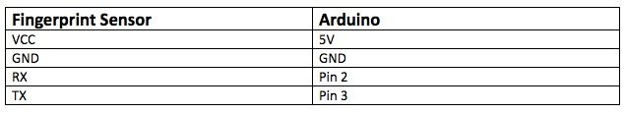

Then connect the I2C LCD module to the UNO. The connections are as follows:

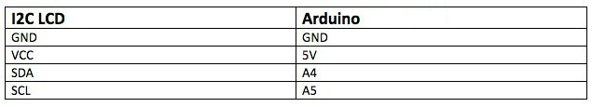

* 1. **WORKING OF MODEL:**
* Relay Module - The relay module is a separate hardware device **used** for remote device switching. Devices can be remotely powered on or off with commands coming from the Arduino Uno board
  + There is one input for the relay module and one for voltage
  + One goes to the connection of ground (as to neutralize it)
* Arduino Uno Board –
  + There are 2 inputs to the board (of the fingerprint scanner)
  + There is 1 input which gives power to the board
  + 1 goes to ground (as to neutralize it)
  1. **IMPLEMENTATION AND CODING:**
* There are two codes we have to upload in our Arduino UNO microprocessor board through Arduino IDE software

1. Finger print Enrollment Code: This code is for the enrollment of our fingerprints with the help of the existing libraries
2. Fingerprint Lock Code: This code will run in loops ie. only if the fingerprint matches then the lock will open.
   * This code will take into consideration all the other components of the model
   1. **CODES USED ARE GIVEN BELOW –**



1. **PERFORMANCE**

After successfully uploading the fingerprints on the fingerprint scanner we can check if its recognizing our print.

If it does then it stores the data in terms of binary codes, through a process called as cryptography (comes in digital forensic).

If the fingerprint which is stored matches the fingerprint which is being scanned then the lock opens.

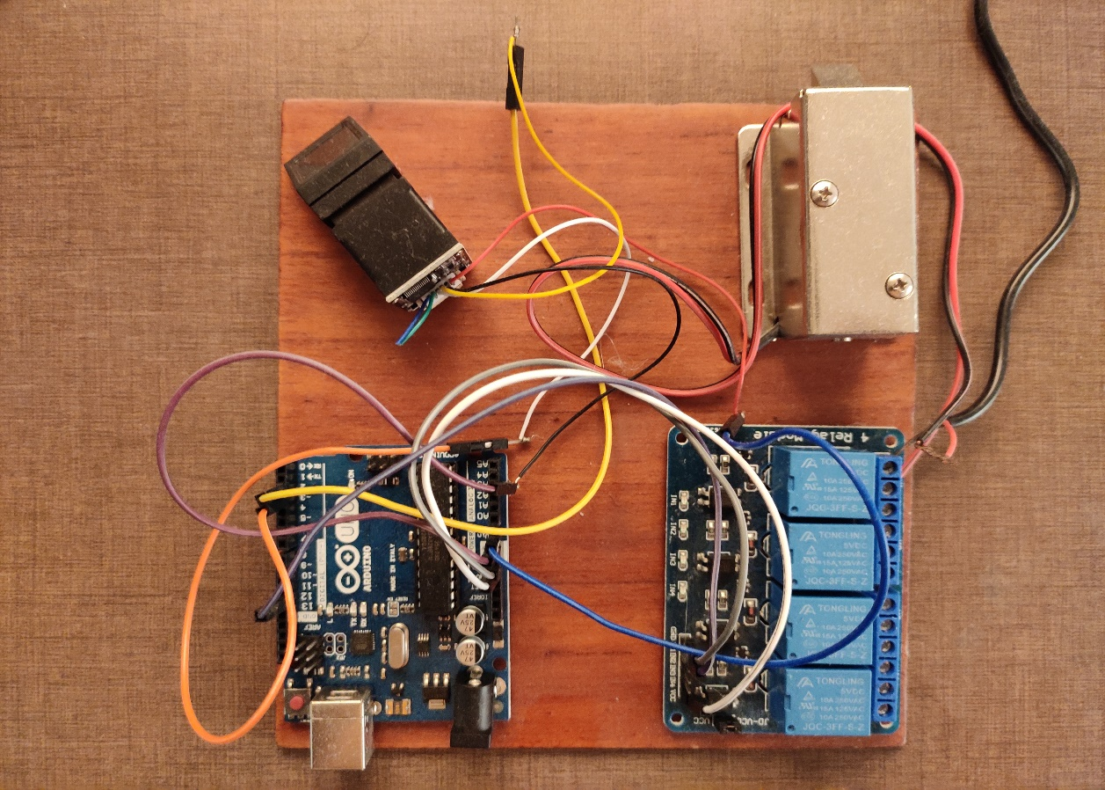**(4.1)**

1. **CONCLUSION**

The design and implementation of fingerprint-based lock system is customizable and flexible. This door locking mechanism is comparatively cost-effective than the available lock systems in the traditional market. Our fingerprint-based lock system has high accuracy rate and is also quick to recognize fingerprints which enable seamless integration with the users and provides tighter security. In our country, private and government organizations are very much concerned about security. Many companies are interested in using this type of locking mechanism but the system which is available have very high installation cost. Due to this excessive cost, many small firms cannot afford such systems. Keeping the installation cost in mind we planned to develop a system that should be affordable to both large and small firms. This design can be improved by more intensive development and additional features such as more locks can be added to the system. Thus we do not need to spend so much for just one lock if this can be used to control several doorways.

1. **REFERENCES**

<https://www.youtube.com/watch?v=SMmj_qAbyeM>

<https://maker.pro/arduino/projects/how-to-create-a-fingerprint-reading-door-lock-system-with-an-arduino-uno>

<https://www.electronoobs.com/eng_arduino_tut41.php>

<https://www.youtube.com/watch?v=4iklgEtV9to>